Contents:

-bibliography

-hypothesis

-methodology

-experiment

-purpose of the article

Bibliography:

-Ashurst, Stephen; Tempesta, Stefano

Blockchain applied. Practical technology and use cases of enterprise blockchain for the real world.

-Yao, Qian; Zhang, Dawei

Survey on identity management in blockchain.

-Liu, Zi-Yu; Guo, Peng-Tao

Supply chain decision model based on blockchain: a case study of fresh food e-commerce supply chain performance improvement.

-Bottoni, Paolo; Labella, Anna

Transactions and contracts based on reaction systems.

-De Giovanni, Pietro

Dynamic quality models and games in digital supply chains. How digital transformation impacts supply chain quality management.

-Morstyn, Thomas; McCulloch, Malcolm D.

Peer-to-peer energy trading.

-Mitani, Tatsuo; Otsuka, Akira

Confidential and auditable payments.

-Abadi, Aydin; Ciampi, Michele; Kiayias, Aggelos; Zikas, Vassilis

Timed signatures and zero-knowledge proofs – timestamping in the blockchain era.

-Cao, Shengjiao; Yuan, Yuan; De Caro, Angelo; Nandakumar, Karthik; Elkhiyaoui, Kaoutar; Hu, Yanyan

Decentralized privacy-preserving netting protocol on blockchain for payment systems.

-Brünnler, Kai; Flumini, Dandolo; Studer, Thomas

A logic of blockchain updates.

-Lian, Wenjuan; Fan, Qi; Jia, Bin; Liang, Yongquan

A blockchain prediction model on time, value, and purchase based on Markov chain and queuing theory in stock trade.

-Ran, Wenxue; Wang, Yan; Yang, Lifan; Liu, Sen

Coordination mechanism of supply chain considering the bullwhip effect under digital technologies.

-Selvi, S. Sharmila Deva; Paul, Arinjita; Dirisala, Siva; Basu, Saswata; Rangan, C. Pandu

Sharing of encrypted files in blockchain made simpler.

-Sharma, Rohit; Kamble, Sachin S.; Gunasekaran, Angappa; Kumar, Vikas; Kumar, Anil

A systematic literature review on machine learning applications for sustainable agriculture supply chain performance.

-Zhao, Wenjuan; Jin, Shunfu; Yue, Wuyi

Analysis of the average confirmation time of transactions in a blockchain system.

-Choudhuri, Arka Rai; Goyal, Vipul; Jain, Abhishek

Founding secure computation on blockchains.

-Anders Brownworth

Hypothesis:

Blockchain technology is a fast and secure way to exchange goods.

Methodology:

The study is meant to analyze the blockchain technology in goods trading and make it easier to understand and more likely to be used by untrained people.

Experiment:

Selling digital art secured by blockchain technology

-easy to copyright sign the artwork

-assuring its authenticity

-assuring its unicity

-selling between artwork's owner and current buyer becomes harder or close to impossible to intercept

Mining is the process where a machine will generate a new hash on the current block based on the previous block’s hash and a unique arbitrary nonce specific to the current blockchain to make sure the mining block is on the same blockchain.

The artwork owner can upload their art on the blockchain where will be kept safe and each temper attempt will be easily visible and invalidated by other blockchain users. Validations are made by checking differences between same block mined on other peers. This can be fast since only >50% chains needs to be checked, validation being dictated by the majority. Also this can imply a huge risk if the blockchain model is not mass adopted, but it will require a lot of hashing power to re-mine at least 51% of all existing blocks to succeed a so called 51% attack.

Ex. 1: A fully correct blockchain

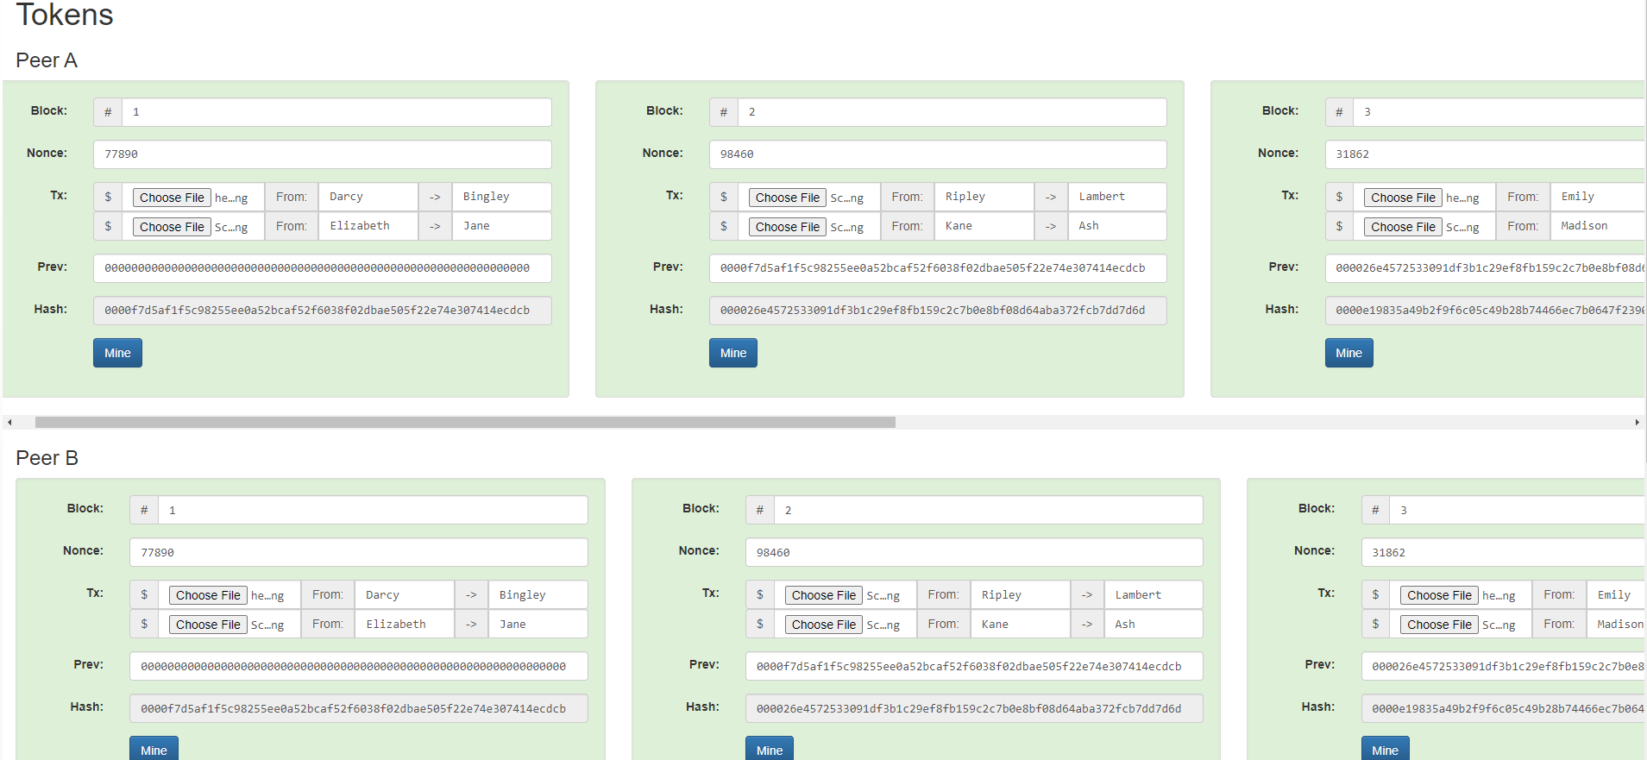

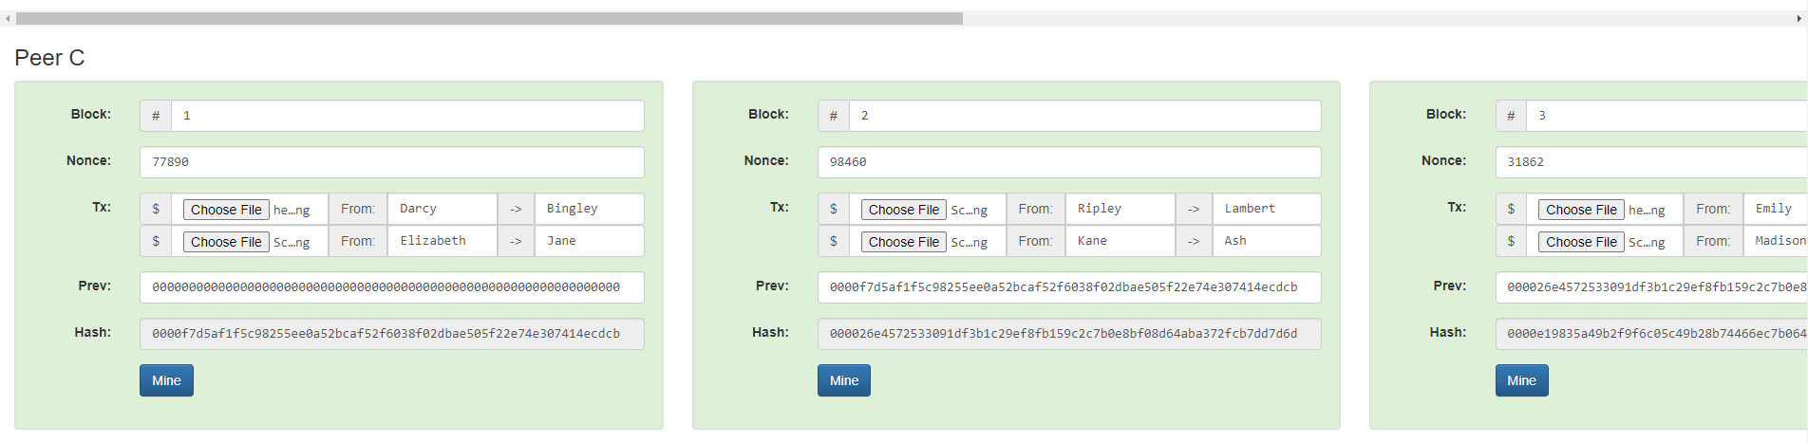

Each peer has the same blockchain with the same data on it

Ex. 2: A tempering attempt on peer B block 2 data

Not time consuming, not using a lot of processing power, but 0 chance of success

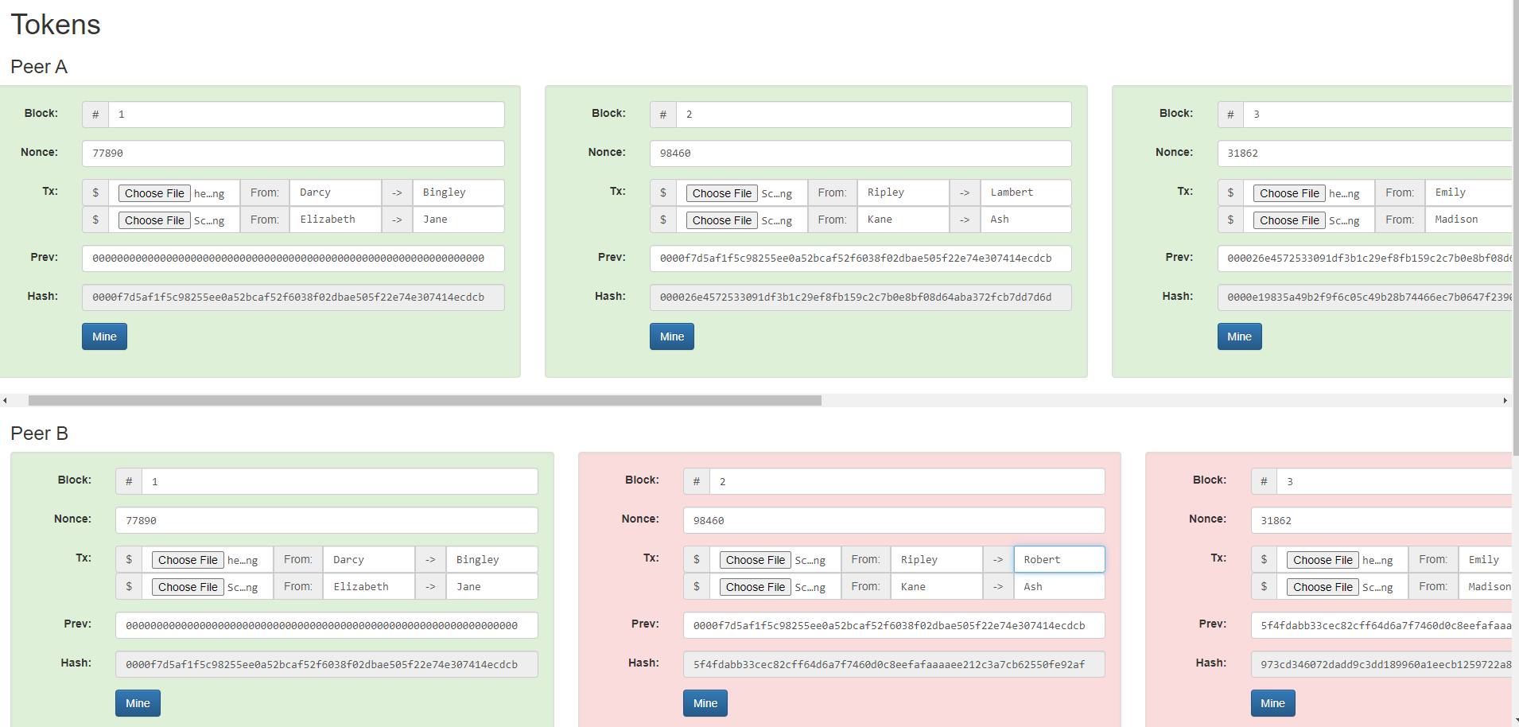

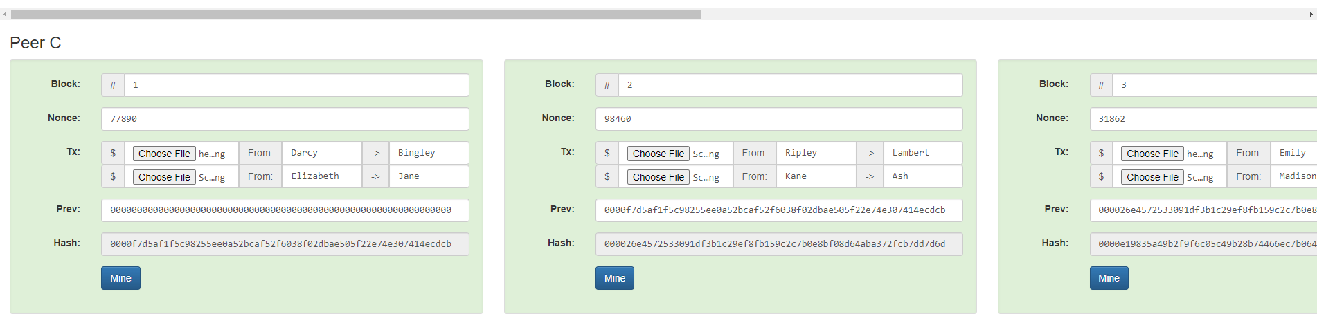

The tempering attempt failed since does not comply with other peers data

Ex. 3: A tempering attempt on all Peer B blockchain data with re-mining the entire blockchain

Time consuming and requires a huge amount of processing power, 0 chances of success

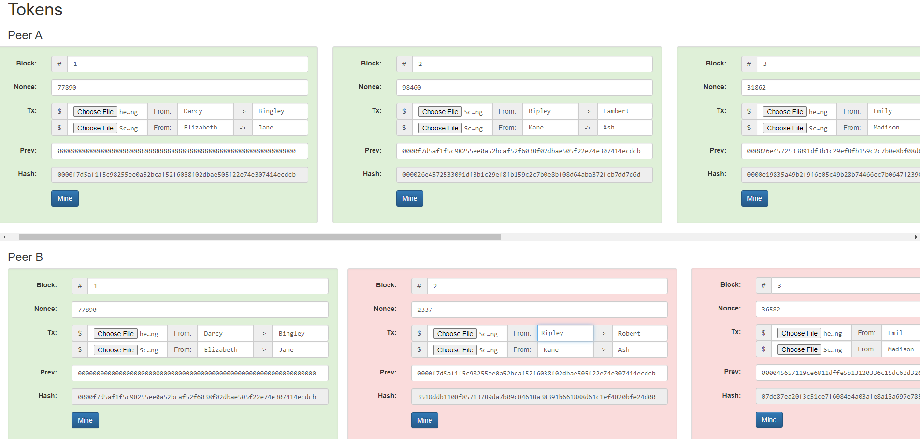

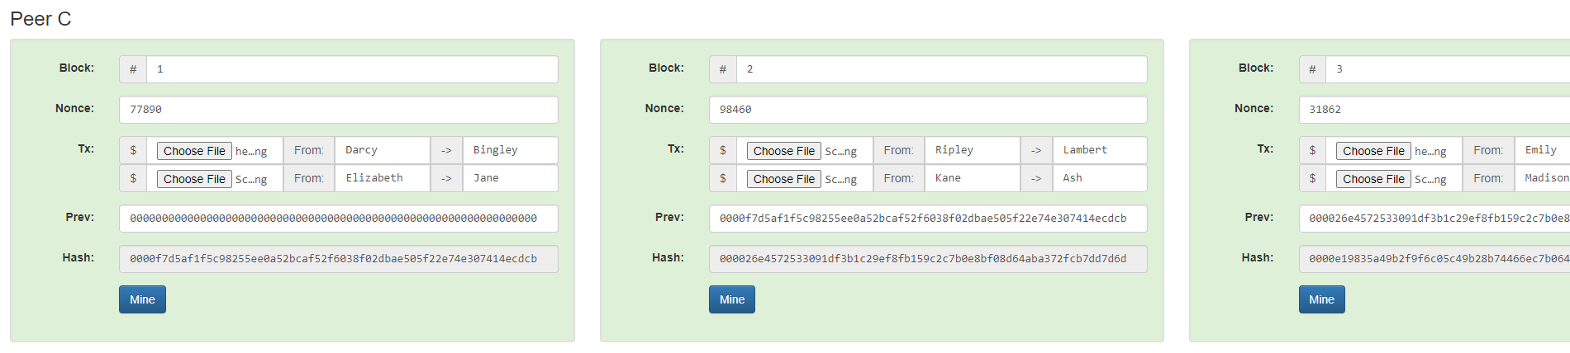

Ex. 4: A 51% attack attempt

Extremely time consuming and it requires an extreme amount of processing power, low chances of success, but not impossible

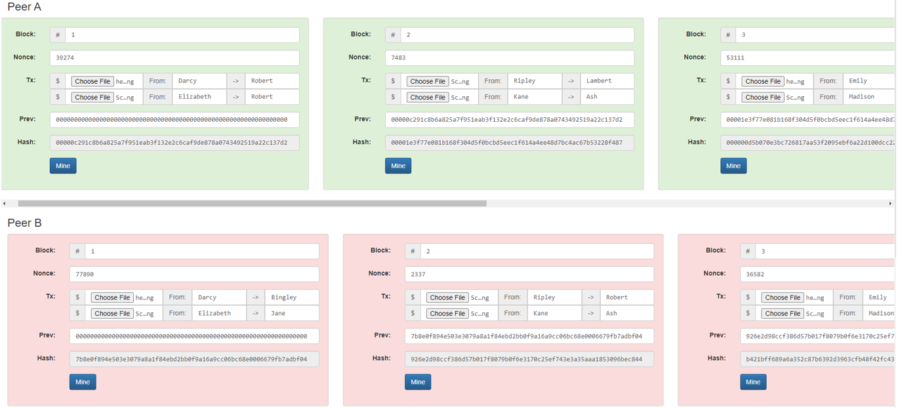

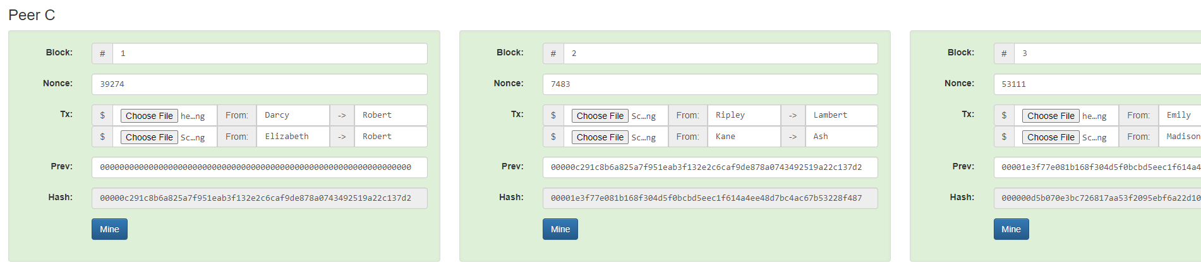

The original block is still correct, but invalidated by the other >50% of the blockchains peers, therefore peer B’s blockchain is the incorrect one.

Purpose of the article

-inform untrained people on the blockchain technology's ease of use and its advantages

-spread mass adoption by making the subject more familiar

-to protect current and future artists and potential buyers from fraud